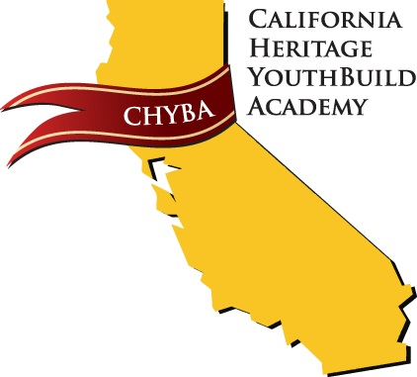

Consent and Registration Form for Rapid COVID-19 Antigen Test

First Name: ____________________________ Last Name: _____________________________
DOB: __________________ Contact Phone Number _________________________________
Guardiant Name:___________________________ Guardian Number:_____________________

School/Testing Site: California Heritage YouthBuild Academy 8544 Airport Rd Redding CA 96002

Please carefully read the following notice and sign the authorization to test for COVID-19.

- I understand that the COVID-19 testing will be conducted through BinaxNOW antigen test, or other acceptable test ordered by an authorized medical provider or public health official.
- I understand that my ability to receive testing is limited to the availability of the test supplies.
- I understand that I am not creating a patient relationship with the ordering physician by participating in this testing. I understand the entity performing the test is not acting as my medical provider. Testing does not replace treatment by my medical provider. I assume complete and full responsibility to take appropriate action with regards to my test results and my medical care. I agree I will seek medical advice, care, and treatment from my medical provider or health care entity if I have questions or concerns, if I develop symptoms of COVID-19, or if my conditions worsen.
- I understand it is my responsibility to inform my health care provider of a positive test result, and that a copy will not be sent to my health care provider for me.
- I understand that my antigen test result will be available in 15-30 minutes. If the result is positive, it will need to be confirmed with a PCR test.
- I understand and acknowledge that a positive antigen test results in an indication that I need to self-isolate to avoid infecting others until I obtain a negative PCR test result.
- I have been informed of the test purpose, procedures, and potential risks and benefits. I will have the opportunity to ask questions before proceeding with a COVID-19 diagnostic test at the testing site. I understand that if I do not wish to continue with the COVID-19 diagnostics test I may not be able to participate in CHYBA activities.
- I understand that to ensure public health and safety and to control the spread of COVID-19, my test results may be shared without my individual authorization.
- I understand that my test results will be disclosed to the appropriate public health authorities as required by law.
- I understand that I may withdraw my consent to participate in testing at any time, and that doing so will forfeit my right to participate in CHYBA activities.

AUTHORIZATION/CONSENT TO TEST FOR COVID-19
- I agree to undergo the COVID-19 antigen testing for the duration of the testing period/authorize my child to undergo testing

___________________________________________ _____________________________
Patient/Parent Legal Guardian Signature Date

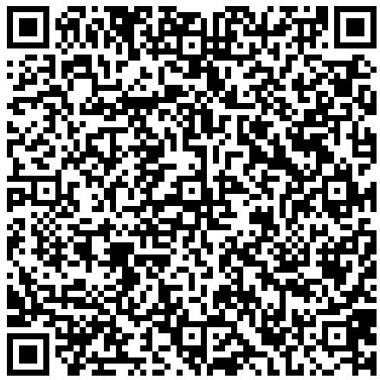
Scan QR Code to register your student and receive test results:

Consent and Registration Form for Rapid COVID-19 Antigen Test

Testing Facility: California Heritage YouthBuild Academy

Address: 8544 Airport Rd. Redding CA. 96002 Phone: 530-378-5254

Personal Information
First Name: ________________________ Last Name: ________________________ MI: ____
Phone Number: (____) ______-___________ Email address: ___________________________
DOB: (____/_____/________) Biological Sex: * Male *Female * Prefer not to answer
Street Address: _______________________________________________________________
City/State/Zip: ________________________________________________________________

Race: Please check the box next to the one that best describes your race.
- American Indian/Alaskan Native
- Black/African American
- Asian
- White/Caucasian
- Hawaiian/Pacific Islander
- Other
- Unknown

Hispanic or Latino: Please check the box next to one of the following that best describes your ethnicity.
- Latino or Hispanic
- No Latino or Hispanic
- Unknown or Decline to specify

Are you vaccinated?
- Yes
- No

Please return completed forms to Dannette Tona, or email at: dtona@chybacharter.com

*I understand that neither I nor my family will be charged directly for services. Consent valid for the 2022/2023 school year.

